Eldritch Horror: Map Design

Overall Map Design

The map has been split into five different levels or zones. The game starts in a street which acts as the starting level. The game then progresses into a sewer level, and as the levels progress the game should become more challenging. The third level is set in a park and then the fourth is set in another street of the city. The final level then takes place in a church.

The overall flow of the game should progress from easy to more difficult so that players have time to get used to the system before they are put in danger. The overall map is also designed to feel like a real city, using areas which can all be commonly found in cities. However, the zones should all also feel different from each other, so the zones have been designed with variety.

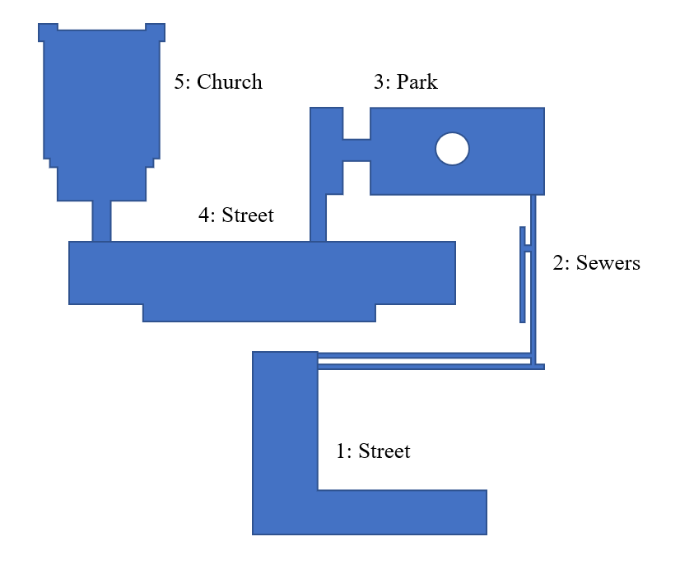

Zone One: Street

I have roughly designed the layout of the first zone, the street. This rough design can be changed in the development of the game if it feels like there are not enough features in the zone or features are too difficult to implement.

I designed the first zone to give a basic introduction to the game by implementing a simple puzzle. This puzzle could also introduce the player to the alternate world feature, and to pass through the gate you might need to enter a word or code that is only visible in this alternate world.

Overall, this zone should be simple in difficulty and introduce the players to the systems of the game. For this reason, I felt that it would be more appropriate not to include any enemies on this level not to give the player not too hard of a start.

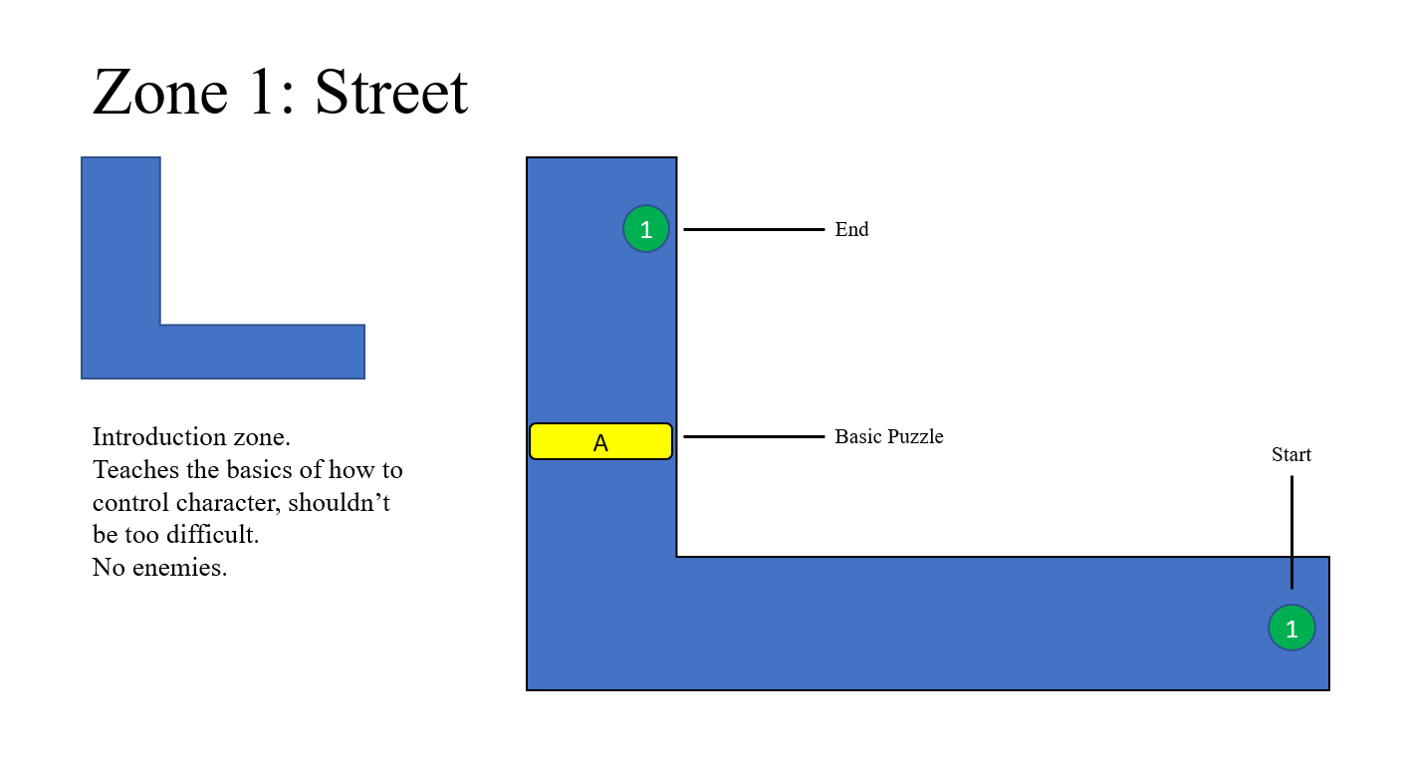

Zone Two: Sewers

The second zone, the sewers, should feel larger than the first and provide the player with more of a challenge. This zone introduces the players to enemies and the combat system of the game. The level design of the sewers should feel different to the design of the other zones, comprised of tight passages and limited movement directions.

In development, the sewer zone could be made larger and contain more passages, but the below map should provide an idea of what the zone should feel like. The zone also includes a health collectable, which would heal the player, unless another method of healing is introduced into the game.

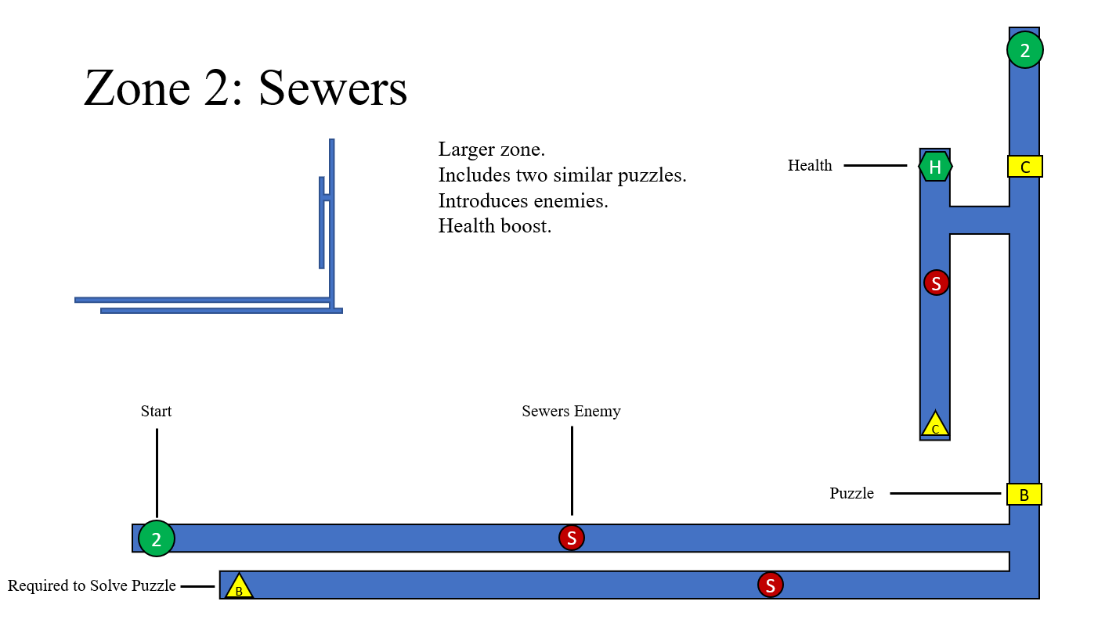

Sewer Puzzles

The puzzles in the sewer would require the player to read the information on the yellow triangle, which would be a code, and input this into a door or blocked passage, which is shown as a square. This would open the door and allow the player to progress. It could be made that the codes can only be seen in the alternate world, or that you must be in the alternate world to input the code.

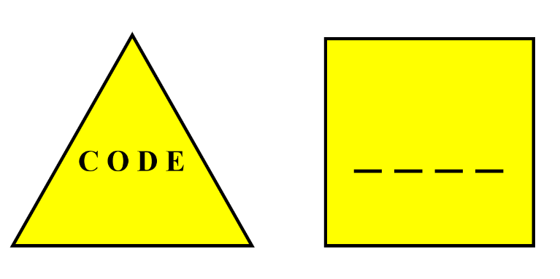

Sewer Enemy

The sewer zone should also introduce the player to the combat system and enemies. Seen as the zone is a sewer, rats would make an appropriate first enemy for the player. They should be a basic enemy and not too difficult to fight. The player may be able to intimidate them if their intimidation level is high enough. These enemies could also only be present in the alternate world, or they could be present in both worlds.

Zone Three: Park

The third zone, the park, should introduce the player to different enemy types and more advanced puzzles. The zone should feel more open than the sewers and offer the player more directions to move in. The puzzle designed in this zone would involve the player turning the statue in the centre to the north. There would be clues in the zone to encourage the player to do this, when the statue is moved, the door marked D should open and allow the player to progress.

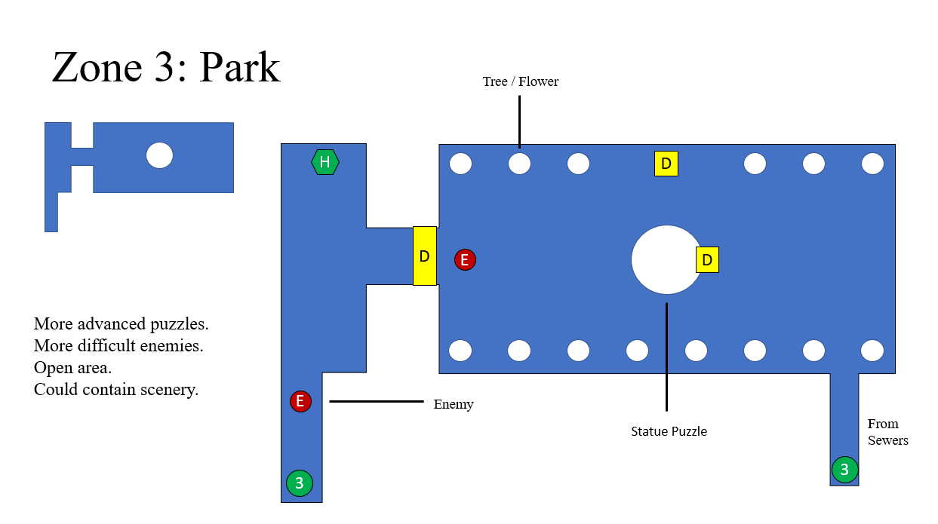

Enemy Design

The enemy introduced in this level will be present in future zones in the game. This enemy should be a still suit of armour in the real world but be a fightable enemy in the alternate world. However, when in the real world and in its statue form, the player should not be able to pass through the enemy. As shown in the map above, this enemy is blocking two passages for the player. Therefore, the player will have to switch into the alternate dimension and defeat the enemy to pass through. I designed to implement this enemy as it makes good use of the alternate dimension mechanic and can be used to block paths and encourage combat.

Zone Four: Street

The fourth zone of the game takes place in another street in the city. However, this should be a more difficult zone than the first street and includes more difficult enemies. It is split up into a path at the top and a path at the bottom, the blank area in the centre is meant to be houses and cannot be passed through by the player. The enemies in this zone are the same from the park.

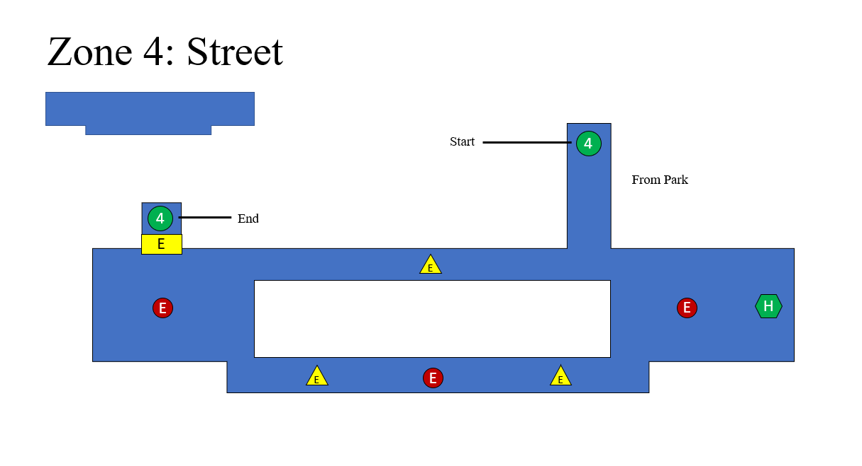

Puzzle Design

The puzzle in this zone is like the zone in the first, where the player must find a code and input it into the door. However, each triangle should only contain part of the contain part of the code, making a word that the player must enter to pass through the door. Seen as there are three parts of the code and the next level is the church, a good fit for this puzzle would have the letters that spell out God be included on the triangles. This should also be a simple word for the player to figure out.

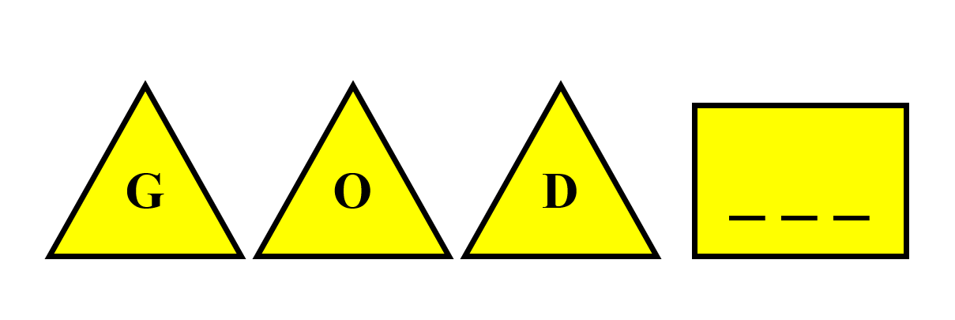

Zone Five: Church

The final zone of the game is the church zone. I decided to have a church as the final level as they are usually found in cities and it gives an atmospheric feeling for a level. The church includes the same statue enemies as the previous level and contains multiple levels. The design of the church below gives a rough idea of what the church should look like, but this can be expanded on or shrunk in the development. The level contains another puzzle where a code must be found and entered, and the zone should end with a fight against a boss enemy which concludes the game.

